FlatCAD Whitepaper
Gabe Johnson, Yeonjoo Oh, Shaun Moon, Mark D Gross
September 16, 2006
Summary
FlatCAD will be an easy-to-use design environment for non-professionals that supports folding, layering, attaching, and trimming flat media such as wood, plastic, paper and metal. Using this software, casual users will be able to easily model objects, allowing exploration of how these objects might fit together in various configurations. If appropriate output devices (such as laser cutters or conventional printers) are available, users may manufacture their designs directly. FlatCAD will differ from existing systems in that it (1) it will provide an intuitive interface to explore the operations that can actually be performed on the medium, and (2) it will be capable of generating physical output if an appropriate device is available. A prototype will be built during the fall of 2006.
Goals
The primary goal of FlatCAD is to support a user in designing things that can be made from flat material using a small set of operations such as folding, layering, attaching, and trimming. The software must be easy to use by non-professional designers. In this document we will provide example constructions that FlatCAD must be capable of creating.
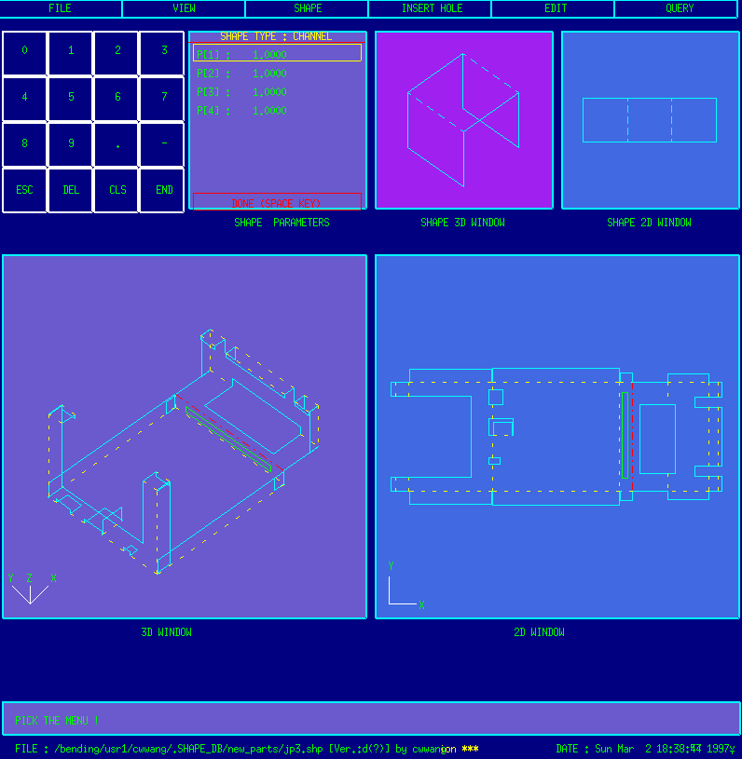
Figure 1: Screen shot of BendCad by Cheng-Hua Wang
Related Work
Researchers at Carnegie Mellon University Robotics Institute’s Rapid Manufacturing Lab have produced academic systems that concern bending and punching sheet metal. The Intelligent Bending Workstation (Wright and Bourne, 1988), (Wang and Bourne, 1995), (Wang and Sturges, 1996) supports punching out shapes from metal sheets and bending the cutouts into shapes. Further work on this topic is demonstrated by Wang in his BendCad Modeler (Wang), (Wang and Bourne, 1997).
Another related academic system is the Intelligent Assembly Modeling and Simulation (IAMS) program (Sinha et al., 2002). IAMS is used to develop assembly simulations and visualizations without the need for physical modeling It offers four major components: (1) an assembly editor, (2) a plan editor, (3) an assembly simulator, and (4) an animation generator/viewer. Of particular interest to FlatCAD is the animation aspect. While FlatCAD will be used to generate physical output, IAMS can generate an animation of the assembly process. A similar process can be used in FlatCAD for helping users in the physical assembly process.
Lipson and Shpitalni identify relationships among geometric properties (e.g. facets, edges, vertices, holes, welds and etc) of the schematic sheet metal parts (Lipson and Shpitalni, 1997). They argue that the relationships among geometric properties help predict a manufacturing process of a metal part without accurate and detailed information.
There are many software tools available in the domains of computer-aided design (CAD), engineering (CAE) and manufacturing (CAM). Typically these tools are classified by their use in industry. Here, we consider two types: Design Modelers and Engineering Modelers. Design Modelers refer to tools used principally by industrial designers, animators, architects, creative artists and similar disciplines. An Engineering Modeler on the other hand refers to a software tool for mechanical engineering, manufacturing design, product engineering and similar.

Design Modelers | Engineering Modelers
Maya -- (Autodesk) | Solidworks – (Solidworks Corp.)
3ds Max -- (Autodesk) | Pro/ENGINEER – (PTC)
AliasStudio -- (Autodesk) | I-deas / NX – (UGS Corp.)
Blender -- (open source) | Solid Edge – (UGS Corp.)
Lightwave -- (NewTek) | Inventor – (Autodesk)
modo -- (Luxology) | CATIA – (Dassault Systemes)
form-Z -- (Auto-des-sys)
Rhinoceros -- (McNeel North America)
SketchUp -- (Google)
Anim8or -- (R. Steven Glanville)
Art of Illusion -- (open source)
Wings 3D -- (open source)

In considering the relationship between FlatCAD and these applications, a specific comparison can be made based on two aspects of these applications. The first aspect is the scope of functionality provided by the program. FlatCAD is constrained to working with planar materials (e.g. cardboard, paper, acrylic sheets, wood sheeting). In contrast all these other applications support high degrees of generality.
The second consideration is the degree of difficulty associated with developing proficiency in a particular CAD/CAE system. Because FlatCAD is a highly specialized application, the number of operations users can perform is limited. This facilitates quick familiarity with the functionality of the application. By virtue of the general functionality of other CAD/CAE systems, the number of operations and functions presented to the user are very long and the processes can be highly complex.
As an extension of FlatCAD’s ease of use, the system provides support for physical representation of the digital artifact. FlatCAD provides users with feedback about how things fit together in the real world. These recommendations are based on the material properties a user chooses for a particular project. This functionality is provided only by the most advanced software tools and usually is only available via plug-ins or other software extensions.
Technical Discussion
FlatCAD forms consist of one or more assemblies. Each assembly is the result of pieces of material that have undergone some sequence of transformations. Thus instead of recording specific three-dimensional points of each vertex, these points are derived based on the constrained operations performed on the flat material. Aside from the traditional reasons to use a constraint-based approach, this method makes sense for two reasons.
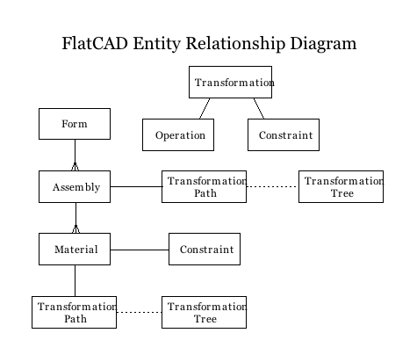
Figure 2: ERD showing the overview of FlatCAD’s architecture
First, from a user interaction perspective the series of transformations may be visualized on screen. The user can see the order of steps that have produced the current form, and optionally go back to previous steps and create alternate variations. A tree structure of transformations enables designers to explore many related options.
Deriving forms as a result of a sequence of transformations also helps FlatCAD enforce physical manufacturing and assembly constraints. For example, a folding operation can be checked to make sure that there the path swept out by the folded piece is free of obstructions. This ensures that any construction modeled with FlatCAD can be manufactured and assembled later on.
We will need to use collision detection techniques in order to help the user avoid creating impossible-to-create designs. Also, how should the program assist the user in establishing and interacting with constraints and forms in 3D?
FlatCAD must also have consideration of material properties. For example, glass won’t bend, but paper will. Certain methods of joining wood together are more stable than others. If a structure is to be load-bearing, is it properly constructed to support the weight of other pieces?
Even though operations such as Fold may appear straightforward, a closer look reveals surprising complexity. We typically think of folding a sheet of paper as though it were a simple two-dimensional object. Real paper in the physical world is not two-dimensional; paper has a thickness that must be accounted for by any software that supports folding or bending. Folding even the thinnest of material requires that the axis of rotation be coplanar with the material.
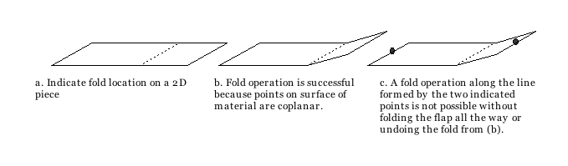
Figure 3: Folds must be peformed in the plane of the material.

Timeline
In the two weeks following this whitepaper we will develop a rough prototype. This initial version will implement part of the above ERD and will serve as an object to think with so we may prepare a better prototype. This first version should be considered a “throwaway”—we may reuse some or all of the code, or we may choose to use a different programming language altogether. The throwaway version should be complete by September 25.
A second, more rigorously designed system will be completed in the first week of November. The purpose of this second prototype is to serve as our demonstration and platform for development of further work.
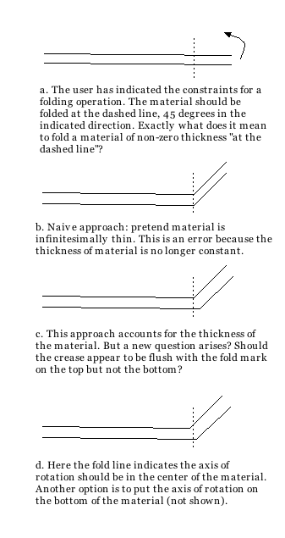
Figure 4: Material thickness and ambiguity of fold line
References
LIPSON, H. & SHPITALNI, M. (1997) On the Topology of Sheet Metal Parts. Trans. of ASME, Journal of Mechanical Design 120, 10 - 16.

SINHA, R., GUPTA, S. K., PAREDIS, C. J. & KHOSLA, P. K. (2002) Extracting articulation models from CAD models of parts with curved surfaces. Journal of Mechanical Design, 124, 106-114.

WANG, C. H. BendCad Web Site: http://www.ri.cmu.edu/projects/project_41.html.

WANG, C. H. & BOURNE, D. A. (1995) Using Features and their Constraints to Aid Process Planning of Sheet Metal Parts. IEEE International on Robotics and Automation.

WANG, C. H. & BOURNE, D. A. (1997) Design and Manufacturing of Sheet Metal Parts: Using Features to Aid Process Planning and Resolve Manufacturability Problems. Robotics and Computer-Integrated Manufacturing, 13, 281-294.

WANG, C. H. & STURGES, R. H. (1996) BendCad: a design system for concurrent multiple representations of parts. Journal of Intelligent Manufacturing, 7, 133-144.

WRIGHT, P. K. & BOURNE, D. A. (1988) Manufacturing Intelligence, Boston, MA, Addison-Wesley Longman Publishing Co., Inc.

Some assembly required

